

IAB206 ASSESSMENT two

Technical Report Task 1



September 11, 2019

SEMESTER TWO

Jiyan Zhu, Shu Du, Gayan Iresh Gunathilaka

Contents

Task1. 2

Create: 2

Read queries: 3

Update: 6

Delete: 12

# Task1.

### Create:

Below is the screenshot of creating one document in Task1. This document contains 2 arrays and 3 embedded documents. By following the similar format, we have inserted 20 documents into the “Assignment1” collection. The code used to create these documents are saved in the “Task1_Create.JSON”.

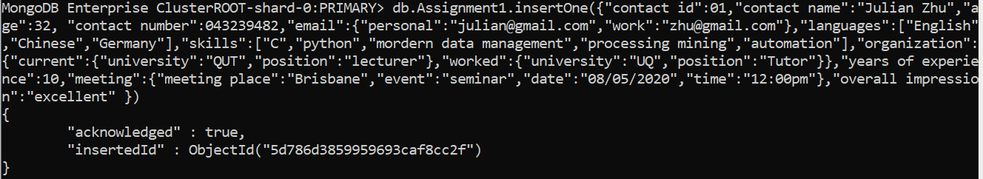

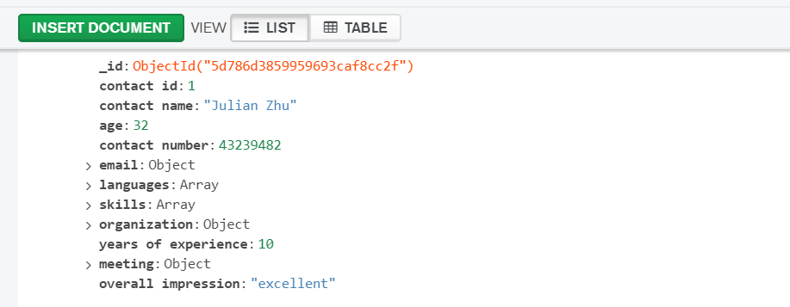

### Read queries:

Question 4.

Write a query that looks for a contact with current organisation as some university and the position as lecturer.

*db.Assignment1.find({"organization.current.position":"lecturer"}).pretty()*

Before:



After:

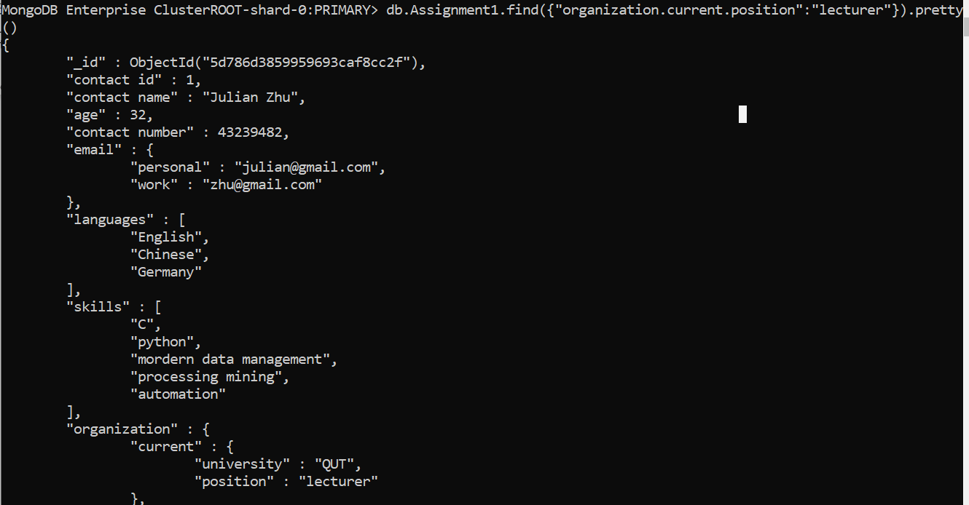

Question 5.

Write a query extracting the name of an individual who has at least one of these skills: ‘modern data management’, ‘process mining’, and ‘automation’.

*db.Assignment1.find({$or: [{"skills":"modern data management"},{"skills":"processing mining"},{"skills":"automation"}]},{"contact name":1})*

**After:**

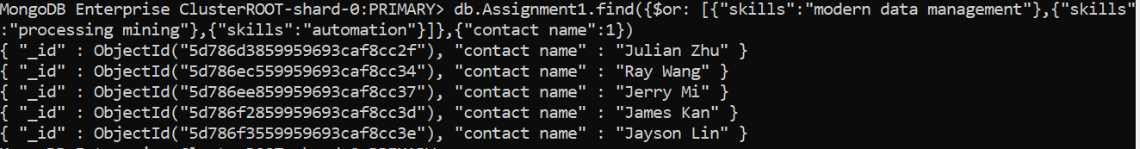

Question 6.

Write a query extracting the name of an individual whose overall impression is ‘good’ and years of experience is greater than or equal to 10.

*db.Assignment1.find({"overall impression":"good","years of experience":{$gte:10}},{"contact name":1})*

**After:**



Question 7.

Create a scenario and mention the data you will need for it. Based on that write your own read query. *Please note that for this question each member in the group needs to have their own individual query. In other words, this question will be marked on an individual basis. In the report when you paste the query and the output, please put the name of the individual group member beside the query s/he created.

Student: **Shu Du** Student Number: **n10505024**

To find people who can do C skills as well as have 10 years or more experience

*db.Assignment1.find({$and:[{"skills":"C"},{"years of experience":{$gt:10}}]}).pretty()*

Student:**Jiyan Zhu** Student Number:**n10415483**

To find people who overall impression is excellent, as well as, currently is working at MIT

*db.Assignment1.find({$and:[{"overall impression":"excellent"},{"organization.current.university":"MIT"}]}).pretty()*

Student **Gayan** **Iresh Gunathilaka**  Student Number: **n9286632**

To find contacts whose age are less than 40 and overall impression is good.

*db.Assignment1.find({$and:[{age:{$lte:40}},{"overall impression":"good"}]}).pretty()*

### Update:

#### Question 8.

Write a query to update the email address of a contact that you have in your database.

*db.Assignment1.updateOne({"contact id":01},{$set:{"email":{"personal":"hello@gmail.com","work":"world@gmail.com"}}})*

**Before:**

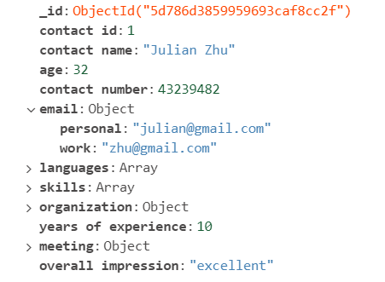

**After:**



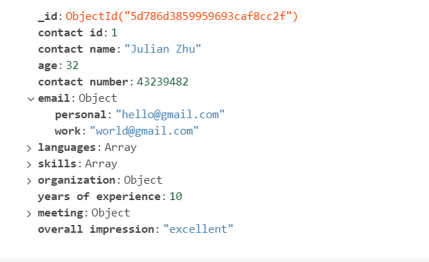

#### Question 9.

Write a query to increment the years of experience of a contact with current organisation of your choice by 2.

*db.Assignment1.updateOne({"contact id":01},{$inc:{"years of experience":2}})*

**Before:**



**After:**



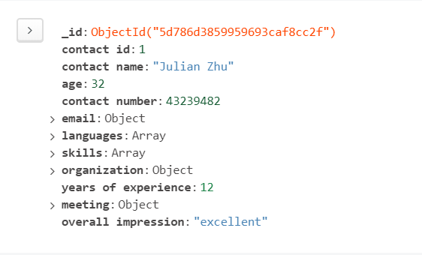

#### Question 10.

Write a query to update the meeting place, date, and time of a contact of your choice.

*db.Assignment1.updateOne({"contact id":01},{$set:{"meeting":{"meeting place":"Thailand","date":"09/09/2020","time":"10:00am"}}})*

**Before:**

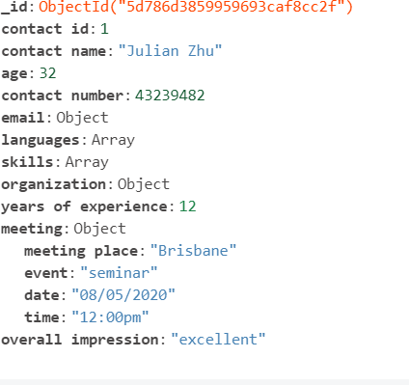

**After:**



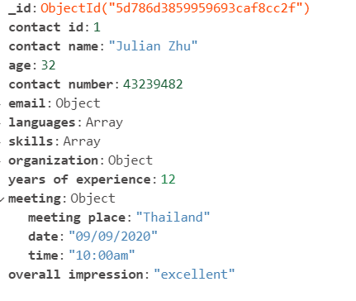

#### Question 11.

Update the value of skill of a contact of your choice from ‘databases’ to ‘modern databases’.

*db.Assignment1.updateOne({"contact id":02},{$set: {"skills.2":"modern databases"}})*

**Before:**

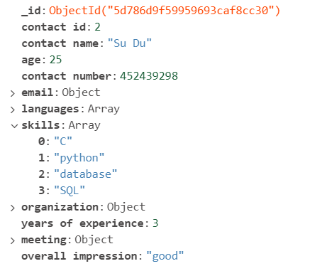

**After:**



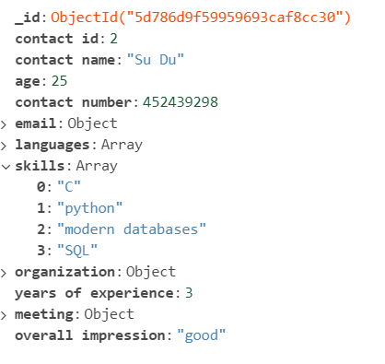

#### Question 12.

Find a contact with the current organisation as ‘QUT’ and update the skills to add a new skill: ‘automation’.

*db.Assignment1.find({"organization.current.university":"QUT"}).pretty()*

*db.Assignment1.update({"contact id":12},{$addToSet:{"skills":"automation"}})*

**Before:**

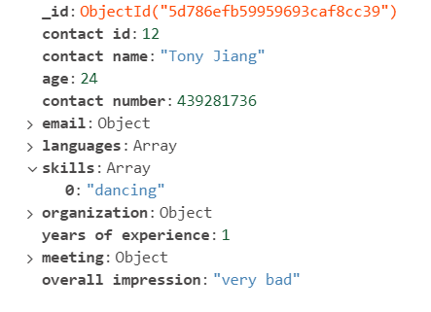

**After:**

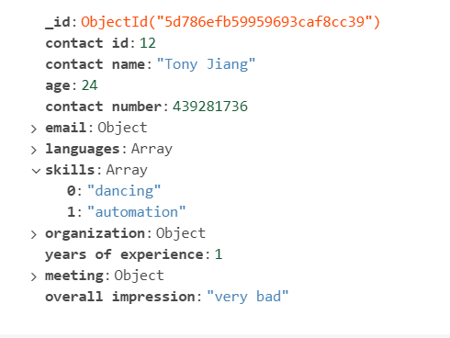

#### Question 13.

Create a scenario and mention the data you will need for it. Based on this scenario you have come up with, write your own update query.

Scenario: Find a contact whose current position is a teacher, change it to be tutor.

*db.Assignment1.find({"organization.current.position":"teacher"}).pretty()*

*db.Assignment1.updateOne({"contact id":14},{$set:{"organization.current.position":"tutor"}})*

**Before:**

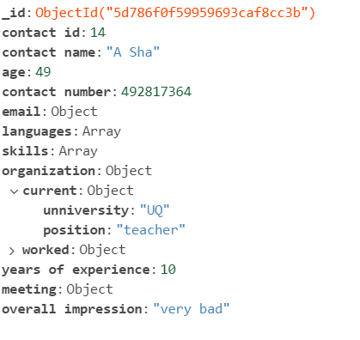

**After:**

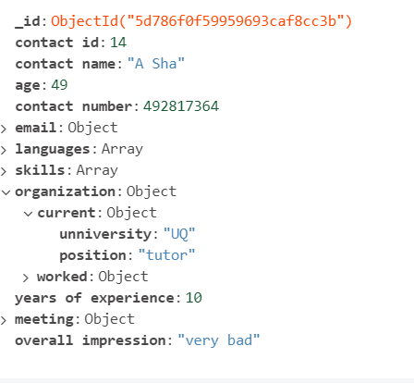

### Delete:

#### Question 14.

Delete a document (i.e. details of a contact) of your choice using a specific condition.

*db.Assignment1.deleteOne({"contact name":"A Sha"})*



#### Question 15.

Delete all documents relating to an organisation of your choice.

*db.Assignment1.remove({"organization.current.university":"QUT"})*

